Literature Review

Contents
1 Introduction 3
2 Procedural Generation in game design 3
2.1 Defining Procedural Generation 3
2.2 Design Motivations and benefits 3
2.3 Applications of Procedural Generation in spatial design 3
2.3.1 Structured Environment Generation: Terrain 3
2.3.2 Structured Environment Generation: Dungeons 4
2.3.3 Algorithmic Approaches to dungeon Generation 5
3 How Dynamic Difficulty Adjustment is used in game design 5
How modern games use Dynamic Difficulty adjustment? 5
NOTES THAT ARE TO BE PUT INTO PARAGRAPHS 6

Figure 1 Bit-Map Terrain Generation Kennard, S. (2021, April 1). A beginner’s look at using Perlin Noise for procedural map generation. Medium. https://samkennard.medium.com/a-beginners-look-at-using-perlin-noise-for-procedural-map-generation-4b8c7f6d2977 4
Figure 2 An example of a graph grammar rule Dormans, J. (n.d.). Adventures in Level Design: Generating Missions and Spaces for Action Adventure Games. [online] Available at: https://pcgworkshop.com/archive/dormans2010adventures.pdf. 5
Figure 3 Shape grammar a) alphabet, b) rules and c) output Dormans, J. (n.d.). Adventures in Level Design: Generating Missions and Spaces for Action Adventure Games. [online] Available at: https://pcgworkshop.com/archive/dormans2010adventures.pdf. 6

1 Introduction
Procedural generation and dynamic difficulty have been in the gaming industry for decades being used in projects separately or together. This paper goes through the different uses for these topics and how they can be used or have been used predominantly in dungeon design however there’s still research in different areas of procedural generation and difficulty to show a better understanding of the topic.

2 Procedural Generation in game design

2.1 Defining Procedural Generation
Procedural Generation (PCG) is a commonly used algorithm which automatically generates data by computer. There are numerous approaches to PCG such as different types of structured environment generation, textures, and models. PCG provides rapid generation of diverse content allowing for replay ability in levels and reduced workload on designers reducing time and money. However this comes at a cost over a lack of control over the generation. Overall PCG in the gaming industry has allowed more time and money to be spent on different tasks with the cost of having either no control or little control. Furthermore, designers who decide on using PCG will be provided with options of semi controlled generation where the user has little input in the generation, or random generation where the contents of the level are purely made through computer generation.

2.2 Design Motivations and benefits
https://web.archive.org/web/20240509013708/https://www.gamedeveloper.com/design/alien-languages-how-we-talk-about-procedural-generation
Design that uses PCG has a multitude of different motivations and benefits. Firstly unlike manually created generation this systems design is never the same, this results in the enhancement of replay ability in game design and variety in models and textures. Secondly with the content being created through an algorithm with little to no human interaction which reduces workload on the designers allowing time to spent on other tasks.

2.3 Applications of Procedural Generation in spatial design

2.3.1 Structured Environment Generation: Terrain
Through out the years there has been numerous different way for procedural generation being used to create terrains, some of these methods include; bitmapping, Fractal terrain and Perlin noise.
Firstly, bitmaps are a technique which takes an image then takes the features on the map which is used to generate detailed data for each small feature. The height for these features is determined by the colour of them on the map. Designers use bitmaps to have specific locations on the map that wouldn’t be generated randomly, allowing the designer to have control over the layout. However this means it needs to have an input meaning human involvement is semi needed. Overall bitmap terrain generation is exceptional when it comes to a controlled option of procedural generation.


Figure 1 Bit-Map Terrain Generation Kennard, S. (2021, April 1). A beginner’s look at using Perlin Noise for procedural map generation. Medium. https://samkennard.medium.com/a-beginners-look-at-using-perlin-noise-for-procedural-map-generation-4b8c7f6d2977
Secondly, fractal terrain
Finally, Perlin noise is a pseudo random procedural generation method that is normally used in 2D generation. Unlike noise, which is a random number generator with no rules, Perlin noise is random with rules. What this means is that during generation rules can be made for more specific generation for example in generation having mountains, pivots in specific spots during generation. This also means that the only limit to what is generated is the rules set by the designer. Overall Perlin noise can be used to generate a range of different terrains if the rules are set by the designer.
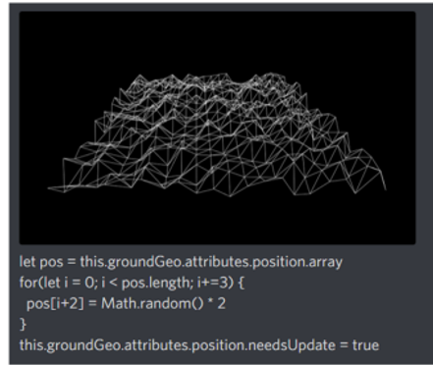
Figure 2 Perlin Noise Generation Kennard, S. (2021, April 1). A beginner’s look at using Perlin Noise for procedural map generation. Medium. https://samkennard.medium.com/a-beginners-look-at-using-perlin-noise-for-procedural-map-generation-4b8c7f6d2977

2.3.2 Structured Environment Generation: Dungeons
https://www.youtube.com/watch?time_continue=328&v=Pwq6OFiQ-lA&embeds_referring_euri=https%3A%2F%2Fwww.google.com%2Fsearch%3Fq%3Droom%2Bbased%2Bworld%2Bgeneration%26oq%3Droom%2Bbased%2Bworld%2Bgeneration%26gs_lcrp%3DEgZjaHJvbWUyBggAEEUYOTIHCAEQI&source_ve_path=MjM4NTE
https://remptongames.com/2018/01/25/going-rogue-like-when-to-use-procedurally-generated-environments-in-games/

Dungeon based procedural generation has been used to show off the different capabilities of procedural generation. Dungeon generation normally uses a method called Room Based World Generation, this uses predesigned or procedurally generated room prefabs and links them through exits while relying on algorithms to place, rotate and connect rooms. The provided option of having predesigned rooms allows there to be high quality levels without the fear of a room not generating properly. The use of mixing different rooms together also keeps the replay able nature of PCG. This method however still has its flaws due to potentially not having enough rooms in selection the dungeon will feel repetitive. Overall if done correctly room-based world generation has a lot of potential in creating high quality dungeons.

2.3.3 Algorithmic Approaches to dungeon Generation
There are countless different algorithms used with procedural generation to generate dungeon levels these include, Graph & shape grammars, Genetic Algorithms, and generative grammars.
Genetic Algorithms are a search-based evolutionary algorithm that try to find an optimal solution to a problem using genetic representation and genetic fitness function. Genetic representation is used to encode a possible solution intro strings which are called genes. Fitness functions are then used to measure the quality of the solutions. The genetic algorithm goes through an iterative process of calculating fitness, selecting and combining the best couple of strings from a population into new strings. During this process a character can randomly change a single character in a string, this process is called mutation, and this ensures that given infinite iterations the optimal solution will be found. Hartsook et al. presented a technique for automatic generation of role-playing game worlds based on a story. The story can be man-made or generated. They map story to game space by using a metaphor of islands and bridges, and capture both in a space tree. Islands are areas where plot points of the story occur. Bridges link islands together (although they are ‘locations’ and not ‘roads’).
Generative grammars normally consist of an alphabet and a set of rules, these rules employ rewrite operations where symbols are replaced by other symbols, these rewrites use right side rule. An example of this is that there may be a rule where ‘S’ is replaced with ‘ab’. Some symbols cannot be replaced as they have no rules connected to them, these symbols are called terminals and are represented by lowercase symbols. In game design grammars can be used to describe games when the alphabet consist of a series of symbols to represent game specific concepts, for example in in dungeon design you could see Dungeon -> Obstacle + treasure or Obstacle -> key + Obstacle + lock + Obstacle.
Graph Grammars are discussed in relation with level generation by David Adams in his 2002 bachelors thesis Automatic Generation of Dungeons for computer Games. They are a specialised for of grammars that uses graphs that consist of edges and nodes. These nodes can be selected for rewriting with a new structure of nodes and edges using the left hand to right hand rule where the character on the left takes on the character of the rights as shown in figure 3. This method is normally used to create the mission structure of the dungeon consisting of the room types for example start, enemy, lock, key, treasure and end rooms. These graphs are designed to be solvable, so the game terminates correctly with the level being in the correct order.
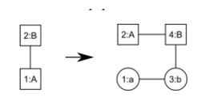
Figure 3 An example of a graph grammar rule Dormans, J. (n.d.). Adventures in Level Design: Generating Missions and Spaces for Action Adventure Games. [online] Available at: https://pcgworkshop.com/archive/dormans2010adventures.pdf.
Shape grammars are used in the creation of space in a level. This is done through using special markers that are used to create space for specific rooms defining starting and ending points for the generated space as shown in figure 4. These come in handy when given a mission structure using symbols due to the symbols being able to be used as building instructions.
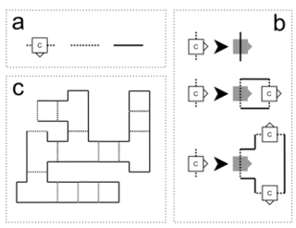
Figure 4 Shape grammar a) alphabet, b) rules and c) output Dormans, J. (n.d.). Adventures in Level Design: Generating Missions and Spaces for Action Adventure Games. [online] Available at: https://pcgworkshop.com/archive/dormans2010adventures.pdf.

Graph grammars and shape grammars assist one another in dungeon creation. Shape grammars use the mission symbols created by the graph grammar to create the space for the dungeons. They benefit one another due to graph grammars being used to build structure with no space, and shape grammar makes space but has no structure. Overall together these methods excels together by filling in the operations the other cannot perform well.

3 How Dynamic Difficulty Adjustment is used in game design

3.?How modern games use Dynamic Difficulty adjustment?
Dynamic Difficulty Adjustment (DDA) is commonly implemented in modern games by adapting difficulty in response to player performance. In Resident evil 4, difficulty is managed with a rank systems having ranks 1 – 10. Player performance stats such as accuracy, damage taken, deaths, dynamically influence this rank. Strong performances increase which will reduce resources and increase enemy aggression, where as failure reduced the rank which decrease the difficulty. This means for newer players they can feel more accomplished when beating an area after dying a lot as this rank is hidden so to them they’re just getting better, so they feel accomplished. However, players may react negatively if adaptive difficulty undermines their skill.

Similarly, Left for Dead 2 uses an AI-driven system known as the “AI Director” which monitors variables such as player health, progression speed, and resource levels. The Director then dynamically adjusts enemy spawn rates and item placement. Unlike normal static difficulties this system introduces change between playthroughs which enhances replay ability. However, adaptive systems that increase difficulty may feel like a punishment for performing strong, for example when high level enemies (e.g. Tanks) are introduced in moments of player vulnerability. Furthermore, players may attempt to exploit the DDA system by maintaining a lower performance to trigger assistance which cannot be changed without interfering with the system.

NOTES THAT ARE TO BE PUT INTO PARAGRAPHS
https://www.shs-conferences.org/articles/shsconf/pdf/2022/14/shsconf_stehf2022_02005.pdf
https://www.redblobgames.com/maps/terrain-from-noise/
https://cmaher.github.io/posts/working-with-simplex-noise/
https://samkennard.medium.com/a-beginners-look-at-using-perlin-noise-for-procedural-map-generation-4b8c7f6d2977

- Procedural generation is an algorithm that can automatically generate data by computer.
- Procedural Generation can be used in many different ways for example terrain generation, content generation and object generation.
- With PCG terrain generation some PCG methods include Fractal Terrain Generation, Bitmap Terrain Generation and Perlin Noise
Fractal Terrian
- Fractal Terrain generation reduces time for developers by reducing the amount of height data the developers have to generate themselves.
- Zhenyuan Shen states that fractal Terrain generations reason for being used as the terrain is self-similar. The horizon of a mountain is not flat it would look rugged, if you zoom in on a part of a hillside it would look uneven and rugged.
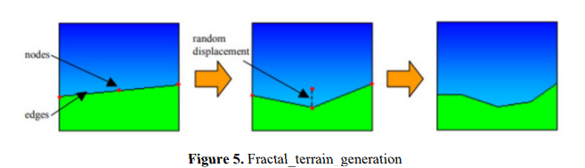
Bitmap
- Bitmap terrain isn’t a completely random technique, normally on the map there are several first features on the map which is used in the process to generate detailed date for each small feature, then the units that make up the map.
- This will mainly be used by designers who want to keep certain functions in several places of the map but don’t really care about the height of these.
- This technique saves a lot of time with it’s map generation compared to manually faces of a plane. A downside of this method is that you have to make the image that goes into the bitmap however this downside can be overlooked for the control you gain over the terrain.
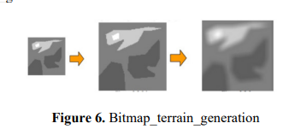

Perlin noise
- Noise function is normally used to generate 2D terrain however normally perlin noise is used.
- The reason for this is because noise is a random number generator with no rules which means it’s very limited in what it can generate however due to Perlin noise being Pseudo random it can have more structure in what it generate making it possible to generate stuff like mountains in nature, or waves that wouldn’t be possible with normal noise.

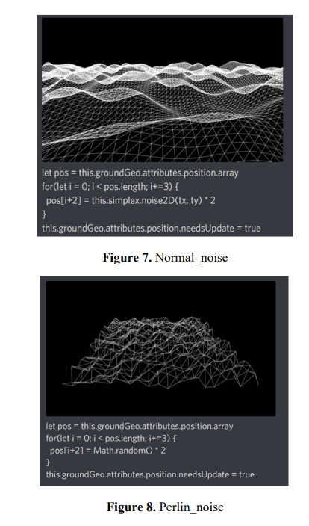

Pseudo random – Date or a sequence that appear random but is produced by a deterministic and repeatable

https://pcgworkshop.com/archive/dormans2010adventures.pdf
- How the graph grammar and shape grammar are used to generate dungeon.
- When using graph grammars it is good to split the contents into space and mission.
- Missions consist of the actions needed to get through the level which is done using graph grammar.
- Space consists of the generated space with shape grammar used to accommodate the mission structure.
- Breaking down the process into two steps allows the use of both strengths of each grammar type to generate interesting levels.

Generative Grammars
- A generative grammar normally consist of an alphabet and a set of rules.
- The rules employ rewrite operations where symbols are replaced by other symbols for example there may be a rule where ‘S’ is to be replaced with ‘ab’, normally symbols the left hand are replaced with symbols on the right side.
- Some symbols cannot be replaced as they have no rules, these symbols are called terminals and are represented by lowercase symbols
- Generative grammars need at least one symbol to replace as it cannot start from nothing.
- In game design grammars can be used to describe games when the alphabet consist of a series of symbols to represent game specific concepts, for example in in dungeon design you could see Dungeon -> Obstacle + treasure or Obstacle -> key + Obstacle + lock + Obstacle. Only one rule will be chosen but you can have it be chosen pseudo randomly.
- Generative grammars can be found in with Lindenmayer systems, Lindenmayer was a biologist who used grammars to describe plant growth, L-Systems are used today in game to generate trees and other natural structures.

Graph Grammars
- Graph Grammars are discussed in relation with level generation by David Adams in his 2002 bachelors thesis Automatic Generation of Dungeons for computer Games.
- They are a specialised form of grammars that does not produced strings but graphs consisting of edges and nodes.
- One or several nodes can be selected for replacement with a new structure of nodes and edges, the replacement works like generative grammars using left hand to right hand side rule.

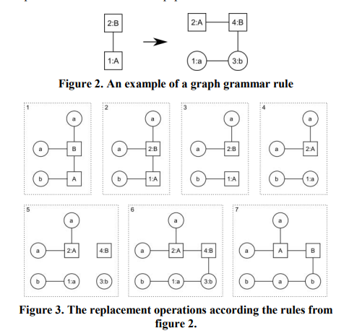
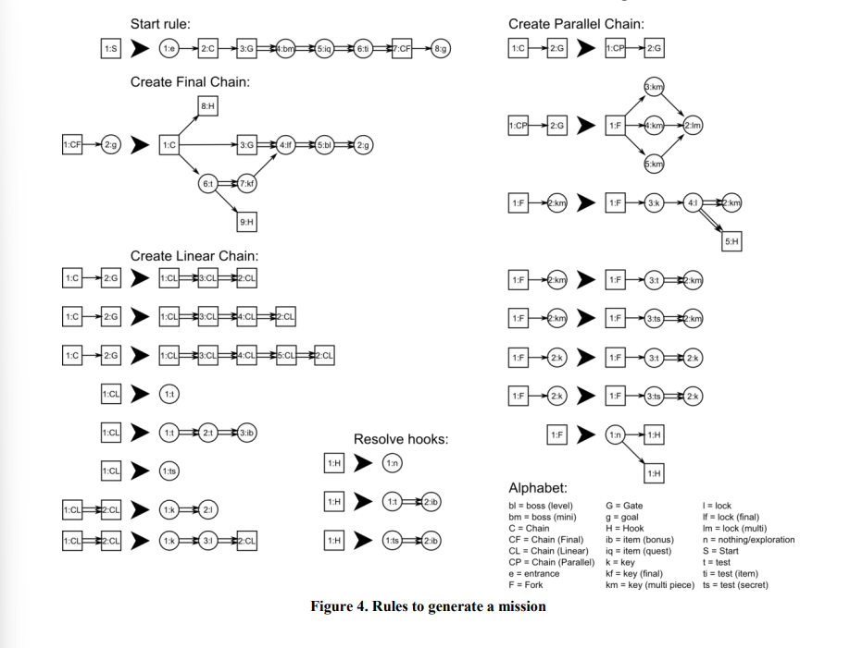

Shape Grammar
- Shape grammars are used best for generating space.
- Shape Grammars are replaced by new shapes following rewrite rules similar to generative grammar and graph grammar, special markers are used to identify starting points and to help orientate the new shapes.
- Shape grammar can be used to generate a space from a generated mission with the terminal symbols working as a building instruction for the shape grammar.
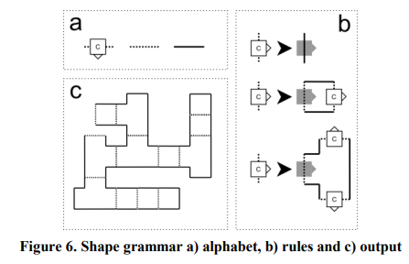

- Why

https://www.researchgate.net/publication/260800341_Procedural_Generation_of_Dungeons
- ‘Current Procedural generation methods aren’t missing performance but are missing control over the generation process.
- PCG has many approaches for example Speed tree was used to generate different trees and integrated in games like Grand Theft Auto IV (Rockstar Games, 2008), and Batman: Arkham Asylum(Eidos Interactive, 2009).
- There has been a lack of commercial use of PCG techniques which most likely has to do with the lack of control.
- There are many pros with procedural generation these being the rapid generation of content, the diversity in the content generated which will increase replay ability, the reduced workload on designers reducing the time and money for the designer that can be spared on something else, and the potential to generate according to the player .
- Dungeons are unique because of the tight bond between designing gameplay and game space, with allowing free exploration but with a strict control over gameplay. What this means is that when generating a dungeon its less about unexpected, interesting results but more over structural control.
- However, there are disadvantages of using PCG which can balance itself out with the advantages, for example the lack of control of the generation means that the algorithm has to be very precise which takes a lot of technical understanding for it to not have mistakes.
- PCG has many different methods that it can benefit from using but as real time performance isn’t essential in its creation what really matters is the structure of the level created.

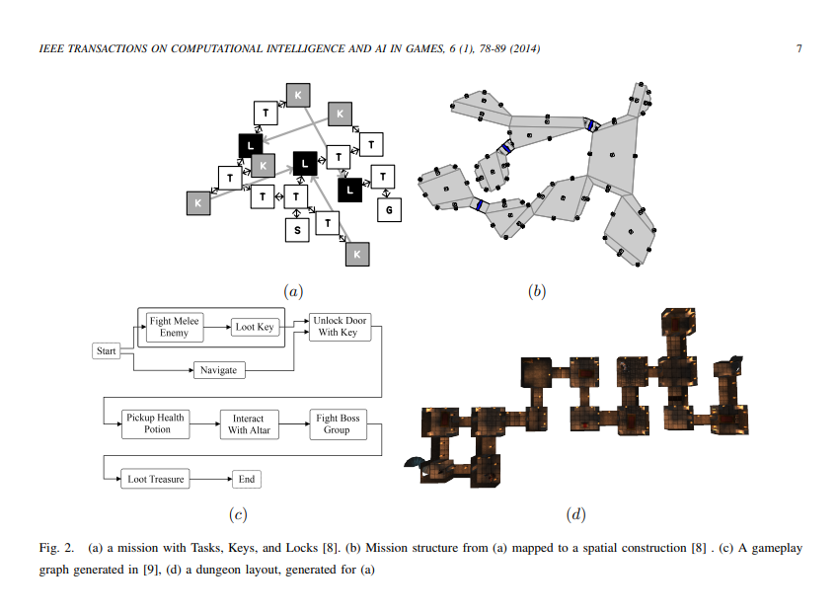
Genetic Algorithms
- Genetic algorithms are search-based evolutionary algorithms that try to find an optimal solution to an optimization problem.
- To use genetic algorithms genetic representation and fitness functions are required.
- Genetic Representation is used to encode possible solution into strings and these are called genes. The fitness functions is used to measure the quality of these solutions.
- The genetic algorithms goes through an iterative process of calculating fitness selecting and combining the best couple of strings from a population into new strings.
- A character can randomly change a single character in a string and this process is called mutation this ensures that given infinite iterations the optimal solution will be found.
- Hartsook et al. presented a technique for automatic generation of role playing game worlds based on a story. The story can be man-made or generated. They map story to game space by using a metaphor of islands and bridges, and capture both in a space tree. Islands are areas where plot points of the story occur. Bridges link islands together (although they are ‘locations’ and not ‘roads’).

https://arxiv.org/pdf/2403.07607
https://journal.stuffwithstuff.com/2014/12/21/rooms-and-mazes/

- The structure of puzzles and graph grammars
- Lock and key puzzles are a popular form of puzzles used in graph grammar dungeon generation. A lock restricts the player from advancing across the level unless a condition is met which is normally obtaining and using a key.
- Graph theory is used to present a conceptual description of a game level and it’s structure, this is known as puzzle graph environment.
- It is a direct graph with labelled nodes of any of the following four styles, begin, end, lock, key.
- These graphs are designed to be solvable making sure the game terminates correctly, for example in structure keys being before locks.
- To structure the puzzles this can be done using graph grammars rewriting symbols .

Dynamic Difficulty
https://faculty.cc.gatech.edu/~riedl/pubs/aiide12.pdf?utm.com

- Players have different levels challenges they can handle this affecting stuff like combat, puzzles, and gameplay.
- Challenge Tailoring is a problem matching the difficulty might not match the specific players ability. CT might manifest as configuring the health, damage dealt by enemies.
- CT is similar to Dynamic Difficulty Adjustment however it isn’t real time.
- Challenge contextualization is the problem of constructing game events that set up conditions for skill events and motivate their occurrence to the player.
- According to Koster 2005 Mastery of skills is correlated with fun, a game that can tailor it’s difficulty to the to meet the needs of the player may be seen as more enjoyable to a wider range of players because it’s never unintentionally boringly easy or frustratingly hard.
https://arxiv.org/pdf/2308.12726
- Difficulty adaption consist of tailoring the difficulty of a given task to match the ability of the person performing it.
- Zohaib said that “DDA is a technique of automatic real-time adjustment of scenarios, parameters, and behaviors in video games, which follows the player’s skill and keeps them from boredom (when the game is too easy) or frustration (when the game is too difficult).”
- What this means that based on the Csikszentmihalyi’s flow theory a balance between challenge of a task and a performers ability is necessary to avoid boredom and frustration.
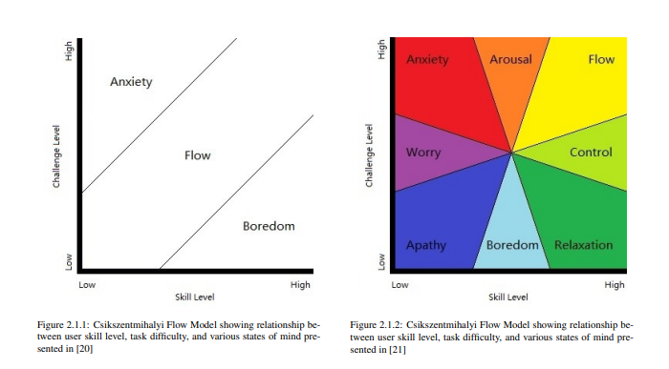
Reinforcement Learning-Based DDA
- RL-Based DDA approaches are different depending if the game is competitive or non competitive.
- For example in competitive games like shooting games players are against an opponent and the opponents expertise determine the difficulty. Whereas with non competitive games the difficulty is decided by the task where completion is required to win.
- In competitive games DDA was accomplished by adjusting the reward or actions of the RL based opponent resulting in changes in the expertise of non human opponents.
https://academicworks.cuny.edu/cgi/viewcontent.cgi?article=7091&context=gc_etds
Static Difficulty Adjustment
- The rate of difficulty is the same for all players so it’s starting at a specific point then going up
- This causes an issue for the player as every players rate of growth is different which could mean the player may either find the game difficulty very boring or very frustrating.
Difficulty setting
- Certain games allows the user the determine the level of difficulty they wish to encounter.
- To do this game developers may create multiple AI agents which perform tasks at different levels.
- The biggest advantage of this method is that the player has control over how they play with being able to make adjustments. However a downside of this is that the game could be designed around a specific difficulty in mind for example fromsoftware, Elden ring want the players to struggle so they learn how to adapt and a difficulty option would take away from the play.
Dynamic Difficulty Adjustment
- DDA involves adapting to the way the player plays the game and bases itself on an estimation of the players skill level and adjusts the environment and the behaviour and skill level of the enemies accordingly.
- DDA has issues with returning in games as you’ll get to a point where you can’t return to previous areas due to the difficulty differences causing an imbalance so it’s not suited for every genre.
Difficulty Adjustment in modern gaming
- In online games the most popular way difficulty is adjusted through updates which could be in the form of new content like new levels, or it could be a reworking of content changing the difficulty of characters or levels.
https://www.gamedeveloper.com/design/game-changers-dynamic-difficulty
https://www.howtogeek.com/theres-a-better-alternative-to-video-game-difficulty-settings-but-nobody-uses-it/?utm_source=chatgpt.com

- How resident evil 4 uses DDA
  - Resident evil 4 uses dynamic adjustment where it uses a system that tracks how frequently the player perishes in recent gameplay. Using this information the game decides whether to ratchet.
  - The game is constantly using a hidden scoring system that is constantly increasing or decreasing depending on performance in combat, these difficulty scales range between 1-10.
  - On standard difficulty it starts at rank 6 but as you go through the game the rank increases with foes becoming tougher and more aggressive or appearing in large numbers. However if you miss shots and die repeatedly this will lower the difficulty
  - Professional mode for the game locks the game to rank 10.
  - Later ports of RE4 introduce easy mode where the difficulty system climbs at a slower rate to the other difficulties.
- How left 4 dead 2 uses DDA
  - L4d2 uses a AI Director which monitors the players health and other performance factors, which is then used to adjust the quantity and location of zombies, ammo and health packs throughout each levels. o
  - For example if
    - Players have 100% health ♣
    - Players have 100% ammo ♣
    - Players are at the end of the level
  - Then
    - Spawn a ‘Tank’ special infected
    - So overall depending on the players skill the director chooses where to place pros and cons.
https://www.researchgate.net/profile/Robin-Hunicke/publication/220982524_The_case_for_dynamic_difficulty_adjustment_in_games/links/53fb98490cf2dca8fffe800a/The-case-for-dynamic-difficulty-adjustment-in-games.pdf?origin=publication_detail&_tp=eyJjb250ZXh0Ijp7ImZpcnN0UGFnZSI6InB1YmxpY2F0aW9uRG93bmxvYWQiLCJwYWdlIjoicHVibGljYXRpb25Eb3dubG9hZCIsInByZXZpb3VzUGFnZSI6InB1YmxpY2F0aW9uIn19&__cf_chl_tk=R6caZBBDDYcrjqor_KKvtvlrD83HuzbdqjewDkE2Buk-1771934281-1.0.1.1-yGmSN0t1.ti9D1ui.EU3AnCR1xWhVzTnwwpsbD37tZo
- Making dynamic difficulty adjustment effective
- Games are boring when they are too easy but frustrating when too hard normally in games difficulty’s is static which leads to mismatches between player skill.
Game Adjustment
  - Game developers iteratively refined game systems based on play testing feedback making changes until the game is balanced
- A successful DDA system must maintain a games internal balance and feedback mechanism.
- To adjust the experience for the player it is necessary to understand how it is designed, the MDA (Mechanics, dynamics and Aesthetics) can be used to help with this.
- This will showcase MDA in an FPS example;
- Mechanics
  - It involves a continueal process of trial and error with loops of exporting, fight, triumph and death as you can see in the figure below
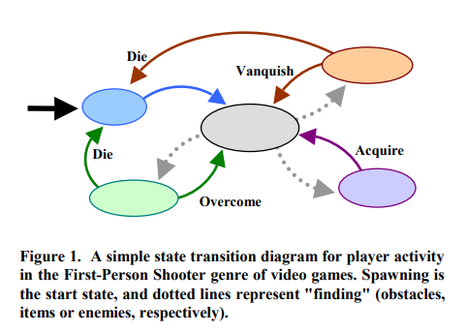
- Dynamics
  - As players go forward from encounter to encounter, and level to level the game the difficulty increase.
  - Players have to get better weapons, health and power ups as during the time of difficulty increase rewards may become scarce.
  - The increasing challenge is the fundamental dynamic of the game
- Aesthetics
  - The mechanics and dynamics come together to create an active fluctuating economy
  - The player understands from previous exposure that overtime aid will taper in frequency as challenge and variability increase, these two dynamics create the aesthetic of the fps genre.
- DDA can create a system using MDA framework where the mechanics are changed, like player health or the amount of enemies being changed which will change the dynamics as the player will have to play differently.

